

DATABASE

SPECIFICATIONS

Next-Gen Restaurant Application
Raditya Fahritama
rkf5230@psu.edu

School of Graduate Professional Studies
Information Science Department
IN SC 521 - Introduction to Database Concepts

Fall II, 2021

Document Control

Work carried out by:
Name | Email Address | Other
Raditya Fahritama | rkf5230@psu.edu | radityafahritama@gmail.com

Revision Sheet

Release No. | Date | Revision Description

DATABASE SPECIFICATIONS

TABLE OF CONTENTS

Document Control i
Work carried out by: i
Revision Sheet i
Milestone 1: Data Requirements 1
System Name or Title 1
Core requirements 1
Milestone 2: Conceptual Design 3
Diagram 3
Assumptions and Constraints 5
Milestone 3: Logical Design 6
Entity Relationship Diagram 6
Assumptions and Constraints 12
Milestone 4: Normalization and 13
Milestone 5: Physical Design 13
Assumptions and Constraints 13
Naming Conventions 13
Tables 13
Milestone 6: SQL queries and 29

Milestone 1: Data Requirements

System Name or Title
Next-Gen Restaurant Application

Core requirements

No. | Requirement | Referenced page in SRS | Referenced Section in SRS | Referenced Paragraph in Section
1 | The system should store information about the customers | 3 | 1.2 | 1
2 | The system should store information about the order of every customer | 3 | 1.2 | 2
3 | The system should store information about reservation that the customer made | 5  12 | 2.1  3.5.6 | 3  1
4 | The system should store information of the items on the menu. | 19  4 | 8.1.1  1.2 | 1  2
5 | The system should store information about the restaurant’s table | 39  54 | 8.1.20  9.5 | 1  1
6 | The system should store information about Restaurant’s staffs | 5 | 2.1 | 3
7 | The system should store information of the user of the application. | 6 | 2.3 | 1
8 | The details of the customers: phone number, ID information, credit card info. | 5  10  58 | 2.2  3.5.3  9.9 | 1  2  1
9 | The details of the Order: Customer ID, table assigned ID, Menu Item ID, ServerID, time of customer visit. | 5  9 | 2.2  3.5 | 1  1
10 | The details of the reservation: receipts related to the reservation, reservation details, wait queue, Table Assigned ID, CustomerID | 12 | 3.5.6 | 1
11 | The details of items on the menu: Item name, item Category, item popularity, item stock | 19  5 | 8.1.1  2.1 | 1  3
12 | Item will have label whether they contain alcohol or not | 8 | 3.1 | 1
13 | Order Payment use three forms of payment: cash, credit card, gift card | 9 | 3.5.1 | 9
14 | The detail of restaurant’s table: table number, table seat type, capacity, table shape, table shape size, Occupancy | 39  54 | 8.1.20  9.5 | 1  1
15 | Table seat is divided to bar and casual dining | 39 | 8.1.20 | 1
16 | The detail about staff: staff schedule | 5 | 2.1 | 3
17 | The detail of User: user age, user role, authentication, user DOB, user Name | 6 | 2.3 | 1
18 | The user roles: Executive team, Restaurant Management, Servers, Host/Hostess, Kitchen Staff, Customer | 6 | 2.3 | 2
19 | The Database should store information about kitchen inventory | 7 | 2.3 | 2
20 | The detail of inventory: Ingredients. | 7 | 2.3 | 2
21 | The database should store information about transaction receipts | 5 | 2.2 | 4
22 | The detail of transaction: Order ID, Payment type. Total. Gratuities, ServerID | 5  9 | 2.2  3.5 | 4  1
23. | The database should store information about Wait queue | 10 | 3.5.3 | 1
24 | The detail of Wait Queue: Customer Name, Party Size, Customer Number | 10 | 3.5.3 | 2

Milestone 2: Conceptual Design

Diagram

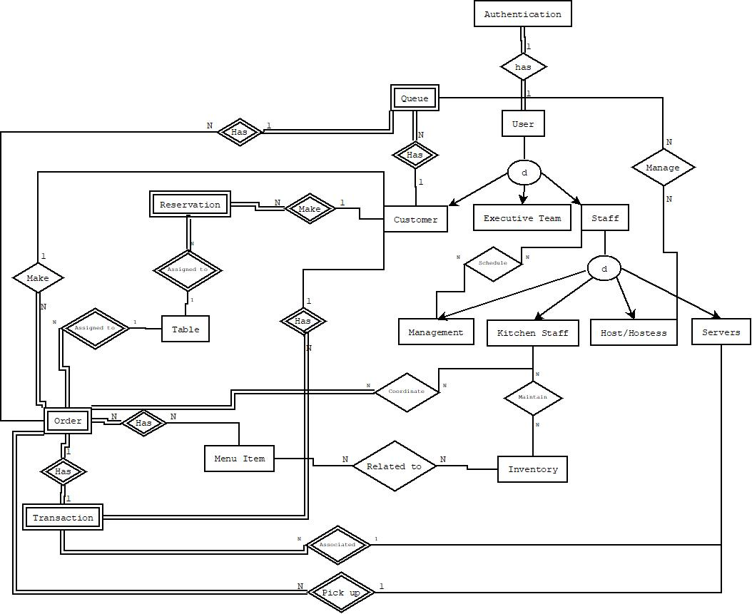

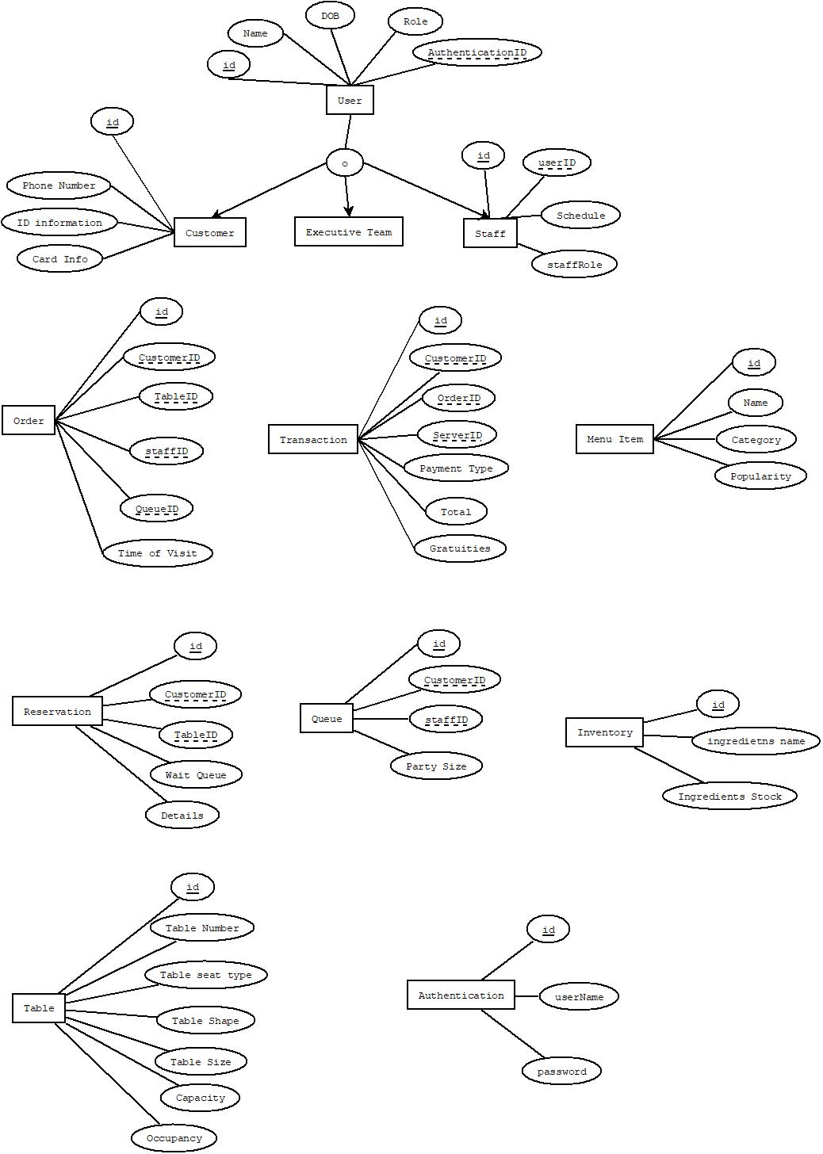

Assumptions and Constraints

-Age is derived from DOB.
-Customer’s phone number is multivalued.
-Order contains ID from Customer, Table, Menu Item, Server.
-Transaction contains ID from Order, Server.
-Reservation contains ID from Customer, Table.
-Queue contains ID from Order, Customer

Milestone 3: Logical Design

Entity Relationship Diagram

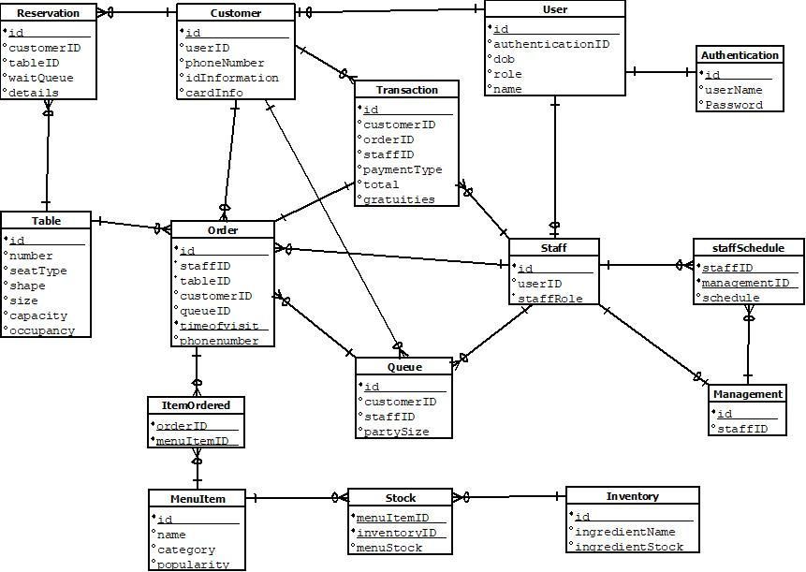

Entity name: User
Attributes:
userID, name, DOB, role, authenticationDetails,
Functional dependencies:
userID -> name, DOB, role, authenticationDetails
Attributes not in FD | Attributes on the left | Attributes on both sides | Attributes on the right side
 | userID |  | Name, DOB, role, authenticationDetails

Attribute closures (if any):
userID+ = userID, name, DOB, role, authenticationDetails
(userID) is a super key

Unique keys: the key for this table is/are
userID

Entity name: Table
Attributes:
tableID, number, seatType, shape, size, capacity, occupancy
Functional dependencies:
tableID -> number, seatType, shape, size, capacity, occupancy
Attributes not in FD | Attributes on the left | Attributes on both sides | Attributes on the right side
 | tableID |  | number, seatType, shape, size, capacity, occupancy

Attribute closures (if any):
tableID + = number, seatType, shape, size, capacity, occupancy
(tableID) is a super key

Unique keys: the key for this table is/are
tableID

Entity name: Staff
Attributes:
staffID, schedule
Functional dependencies:
staffID -> schedule
Attributes not in FD | Attributes on the left | Attributes on both sides | Attributes on the right side
 | staffID |  | schedule

Attribute closures (if any):
staffID+ = staffID, schedule
(staffID) is a super key

Unique keys: the key for this table is/are
staffID

Entity name: Inventory
Attributes:
inventoryID, ingredientsName, ingredientsStock
Functional dependencies:
inventoryID -> ingredientsName, ingredientsStock
Attributes not in FD | Attributes on the left | Attributes on both sides | Attributes on the right side
 | inventoryID |  | ingredientsName, ingredientsStock

Attribute closures (if any):
inventoryID+ = inventoryID, ingredientsName, ingredientsStock
(inventoryID) is a super key

Unique keys: the key for this table is/are
inventoryID

Entity name: MenuItem
Attributes:
menuItemID, name, category, popularity, stock
Functional dependencies:
menuItemID -> name, category, popularity, stock
Attributes not in FD | Attributes on the left | Attributes on both sides | Attributes on the right side
 | menuItemID |  | name, category, popularity, stock

Attribute closures (if any):
menuItemID+ = menuItemID, name, category, popularity, stock
(menuItemID) is a super key

Unique keys: the key for this table is/are
menuItemID

Entity name: Staff
Attributes:
staffID, schedule
Functional dependencies:
staffID -> schedule
Attributes not in FD | Attributes on the left | Attributes on both sides | Attributes on the right side
 | staffID |  | schedule

Attribute closures (if any):
staffID+ = staffID, schedule
(staffID) is a super key

Unique keys: the key for this table is/are
staffID

Entity name: Order
Attributes:
orderID, customerID, tableID, menuItemID, serverID, queueID, timeOfVisit
Functional dependencies:
orderID -> customerID, tableID, menuItemID, serverID, queueID, timeOfVisit
Attributes not in FD | Attributes on the left | Attributes on both sides | Attributes on the right side
 | orderID |  | customerID, tableID, menuItemID, serverID, queueID, timeOfVisit

Attribute closures (if any):
orderID+ = orderID, customerID, tableID, menuItemID, serverID, queueID, timeOfVisit
(orderID) is a super key

Unique keys: the key for this table is/are
orderID

Entity name: Queue
Attributes:
queueID, customerID, customerName, partySize, customerNumber
Functional dependencies:
queueID -> customerID, customerName, partySize, customerNumber
Attributes not in FD | Attributes on the left | Attributes on both sides | Attributes on the right side
 | queueID |  | customerID, customerName, partySize, customerNumber

Attribute closures (if any):
queueID+ = queueID, customerID, customerName, partySize, customerNumber
(queueID) is a super key

Unique keys: the key for this table is/are
queueID

Entity name: Transaction
Attributes:
transactionID, orderID, serverID, paymentType, total, gratuities
Functional dependencies:
transactionID -> orderID, serverID, paymentType, total, gratuities
Attributes not in FD | Attributes on the left | Attributes on both sides | Attributes on the right side
 | transactionID |  | orderID, serverID, paymentType, total, gratuities

Attribute closures (if any):
transactionID+ = transactionID, orderID, serverID, paymentType, total, gratuities
(transactionID) is a super key

Unique keys: the key for this table is/are
transactionID

Entity name: Reservation
Attributes:
reservationID,
Functional dependencies:
reservationID -> customerID, tableID, waitQueue, details
Attributes not in FD | Attributes on the left | Attributes on both sides | Attributes on the right side
 | reservationID |  | customerID, tableID, waitQueue, details

Attribute closures (if any):
reservationID+ = reservationID, customerID, tableID, waitQueue, details
(reservationID) is a super key

Unique keys: the key for this table is/are
reservationID

Assumptions and Constraints
-Order contains ID from Customer, Table, Menu Item, Server.
-Transaction contains ID from Order, Server.
-Reservation contains ID from Customer, Table.
-Queue contains ID from Order, Customer

Milestone 4: Normalization and

Milestone 5: Physical Design

Assumptions and Constraints
-Order contains ID from Customer, Table, Menu Item, Server.
-Transaction contains ID from Order, Server.
-Reservation contains ID from Customer, Table.
-Queue contains ID from Order, Customer

Naming Conventions

Discuss the naming standards and conventions that you have used for table creation.

Tables

 | Name of the table | User
 | Description | User of the application
 | Attribute | Description |  | Type | Examples of values | Notes
 | userID | Id of user |  | Integer | Between 1 and 999999
 | authenticationID | Id of related authentication detail |  | Integer | Between 1 and 999999
 | dob | Date of birth of user |  | date | 1/1/1999 | Must be bigger than 1/1/1900
 | role | Role of the user |  | Varchar(50) | CUSTOMER | 3 types of role: customer, executive team, staff
 | Name | name of the user |  | Varchar(50) | Andrew
 | Functional Dependencies and Keys
 | Functional dependencies | userID -> authenticationID  userID -> dob  userID -> role  userID -> name  authenticationID -> username, password
 | Candidate keys | userID, authenticationID
 | Normalization
 | 1NF | Yes | All cells contain a unique value
 | 2NF | Yes | The key of the table is a single attribute
 | 3NF | Yes | All the non-key attributes depend only on a key
 | BCNF | Yes | All the attributes depend only on a key
 | Physical Design
 | Primary Key | userID
 | Foreign Keys | authenticationID
 | SQL Code | CREATE TABLE P_USER(  USERID INTEGER,  AUTHENTICATIONID INTEGER,  USERDOB DATE,  USERROLE VARCHAR(50) NOT NULL,  USERNAME VARCHAR(50) NOT NULL,  CONSTRAINT P_USER PRIMARY KEY (USERID),  FOREIGN KEY (AUTHENTICATIONID) REFERENCES "P_AUTHENTICATION"(AUTHENTICATIONID),  CHECK (USERROLE = 'CUSTOMER' OR USERROLE = 'EXECUTIVE TEAM' OR USERROLE = 'STAFF'),  CHECK (USERDOB > TO_DATE('1900/1/1', 'YYYY/MM/DD'))  );
 | Count of records in the table | 6

...
 | Name of the table | Authentication
 | Description | Contains username and password of user
 | Attribute | Description |  | Type | Examples of values | Notes
 | authenticationID | Id of authentication |  | integer | Between 1 and 999999
 | username | Username of user |  | Varchar(20) | Asdfg1236 | Cannot be null
 | password | Password of user |  | Varchar(20) | Testpassword7 | Cannot be null
 | Functional Dependencies and Keys
 | Functional dependencies | authenticationID -> username  authenticationID -> password
 | Candidate keys | authenticationID
 | Normalization
 | 1NF | Yes | All cells contain a unique value
 | 2NF | Yes | The key of the table is a single attribute
 | 3NF | Yes | All the non-key attributes depend only on a key
 | BCNF | Yes | All the attributes depend only on a key
 | Physical Design
 | Primary Key | authenticationID
 | Foreign Keys | -
 | SQL Code | CREATE TABLE P_AUTHENTICATION(  AUTHENTICATIONID INTEGER,  USERNAME VARCHAR(50) NOT NULL,  PASSWORD VARCHAR(50) NOT NULL,  CONSTRAINT P_AUTHENCTICATION PRIMARY KEY(AUTHENTICATIONID)  );
 | Count of records in the table | 6

 | Name of the table | Customer
 | Description | The customer of the restaurant. Also the user of the application
 | Attribute | Description |  | Type | Examples of values | Notes
 | customerID | Id of the customer |  | integer | Between 1 and 999999
 | userID | Id of related user and customer |  | integer | Between 1 and 999999
 | phoneNumber | Number of the customer |  | Char(10) | 5451231234
 | idInformation | Id number of the customer |  | Char(12) | 0909090908080808
 | cardInfo | Card number of the customer |  | Char(12) | 0101020203030404
 | Functional Dependencies and Keys
 | Functional dependencies | customerID -> userID  customerID -> phoneNumber  customerID -> idInformation  customerID -> cardInfo  userID -> authenticationID, dob, role, name  authenticationID -> username, password
 | Candidate keys | customerID, userID, authenticationID
 | Normalization
 | 1NF | Yes | All cells contain a unique value
 | 2NF | Yes | The key of the table is a single attribute
 | 3NF | Yes | All the non-key attributes depend only on a key
 | BCNF | Yes | All the attributes depend only on a key
 | Physical Design
 | Primary Key | customerID
 | Foreign Keys | userID
 | SQL Code | CREATE TABLE P_CUSTOMER(  CUSTOMERID INTEGER,  USERID INTEGER,  PHONENUMBER CHAR(10),  IDINFORMATION CHAR(12),  CARDINFO CHAR(12),  CONSTRAINT P_CUSTOMER PRIMARY KEY (CUSTOMERID),  FOREIGN KEY (USERID) REFERENCES "P_USER"(USERID),  CHECK(PHONENUMBER NOT LIKE '%[^0-9]%'),  CHECK(IDINFORMATION NOT LIKE '%[^0-9]%'),  CHECK(CARDINFO NOT LIKE '%[^0-9]%')  );
 | Count of records in the table | 2

 | Name of the table | Staff
 | Description | The staff of the restaurant. Also the user of the application.
 | Attribute | Description |  | Type | Examples of values | Notes
 | staffID | Id of staff |  | integer | Between 1 and 999999
 | userID | Id of the related user and staff |  | integer | Between 1 and 999999
 | staffRole | Role of the staff |  | Varchar(20) | Host | 4 types of roles: manager, kitchen staff, host/hostess, servers
 | Functional Dependencies and Keys
 | Functional dependencies | staffID -> userID  staffID -> staffRole  userID -> authenticationID, dob, role, name  authenticationID -> username, password
 | Candidate keys | staffID, userID, authenticationID
 | Normalization
 | 1NF | Yes | All cells contain a unique value
 | 2NF | Yes | The key of the table is a single attribute
 | 3NF | Yes | All the non-key attributes depend only on a key
 | BCNF | Yes | All the attributes depend only on a key
 | Physical Design
 | Primary Key | staffID
 | Foreign Keys | userID
 | SQL Code | CREATE TABLE P_STAFF(  STAFFID INTEGER,  USERID INTEGER,  STAFFROLE VARCHAR(20),  CONSTRAINT P_STAFF PRIMARY KEY(STAFFID),  FOREIGN KEY (USERID) REFERENCES "P_USER"(USERID),  CHECK(STAFFROLE = 'MANAGER' OR STAFFROLE = 'KITCHEN STAFF' OR STAFFROLE = 'HOST/HOSTESS' OR STAFFROLE = 'SERVER')  );
 | Count of records in the table | 4

 | Name of the table | Queue
 | Description | Queue of the restaurant. Customer has to be assigned to queue before entering restaurant.
 | Attribute | Description |  | Type | Examples of values | Notes
 | queueID | Id of the queue |  | integer | Between 1 and 999999
 | customerID | Id of related customer and queue |  | integer | Between 1 and 999999
 | staffID | Id of related staff and queue |  | integer | Between 1 and 999999
 | partySize | How much people in one queue |  | integer | Between 1 and 100 | Cannot be null
 | Functional Dependencies and Keys
 | Functional dependencies | queueID-> customerID  queueID -> staffID  queueID -> partySize  customerID-> userID, phoneNumber,idInformation,cardInfo  staffID->userID, staffRole  userID -> authenticationID, dob, role, name
 | Candidate keys | queueID, customerID, staffID, userID
 | Normalization
 | 1NF | Yes | All cells contain a unique value
 | 2NF | Yes | The key of the table is a single attribute
 | 3NF | Yes | All the non-key attributes depend only on a key
 | BCNF | Yes | All the attributes depend only on a key
 | Physical Design
 | Primary Key | queueID
 | Foreign Keys | customerID, staffID
 | SQL Code | CREATE TABLE P_QUEUE(  QUEUEID INTEGER,  CUSTOMERID INTEGER,  STAFFID INTEGER,  PARTYSIZE INTEGER NOT NULL,  CONSTRAINT P_QUEUE PRIMARY KEY(QUEUEID),  FOREIGN KEY (CUSTOMERID) REFERENCES "P_CUSTOMER"(CUSTOMERID),  FOREIGN KEY (STAFFID) REFERENCES "P_STAFF"(STAFFID)  );
 | Count of records in the table | 2

 | Name of the table | Reservation
 | Description | Reservation to the restaurant. Reservation that is made by customer will be recorded here.
 | Attribute | Description |  | Type | Examples of values | Notes
 | reservationID | Id of the reservation |  | integer | Between 1 and 999999
 | customerID | Id of the related customer and reservation |  | integer | Between 1 and 999999
 | tableID | Id of related table and reservation |  | integer | Between 1 and 999999
 | waitQueue | Queue position of the reservation |  | integer | Between 1 and 100 | Cannot be null
 | details | Reservation details |  | Varchar(50) | Reservation of mr.john
 | Functional Dependencies and Keys
 | Functional dependencies | reservationID-> customerID  reservationID-> tableID  reservationID-> waitQueue  reservationID-> details  customerID-> userID, phoneNumber,idInformation,cardInfo  tableID->number, seatType, shape, size, capacity, occupancy  userID -> authenticationID, dob, role, name
 | Candidate keys | reservationID, customerID, tableID, userID
 | Normalization
 | 1NF | Yes | All cells contain a unique value
 | 2NF | Yes | The key of the table is a single attribute
 | 3NF | Yes | All the non-key attributes depend only on a key
 | BCNF | Yes | All the attributes depend only on a key
 | Physical Design
 | Primary Key | reservationID
 | Foreign Keys | customerID, tableID
 | SQL Code | CREATE TABLE P_RESERVATION(  RESERVATIONID INTEGER,  CUSTOMERID INTEGER,  TABLEID INTEGER,  WAITQUEUE INTEGER NOT NULL,  DETAILS VARCHAR(50),  CONSTRAINT P_RESERVATION PRIMARY KEY (RESERVATIONID),  FOREIGN KEY (CUSTOMERID) REFERENCES "P_CUSTOMER"(CUSTOMERID),  FOREIGN KEY (TABLEID) REFERENCES "P_TABLE"(TABLEID)  );
 | Count of records in the table | 2

 | Name of the table | Table
 | Description | Record of tables of the restaurant. Provides details of the tables.
 | Attribute | Description |  | Type | Examples of values | Notes
 | tableID | Id of the table |  | integer | Between 1 and 999999
 | Number | Number of the table |  | Char(2) | Numeric from 01 to 99
 | seatType | Seat type of the table |  | char(6) | CASUAL | 2 types. Casual dining and Bar.
 | Shape | The table shape |  | Varchar(10) | ROUND | 2 types. Square and round.
 | Size | Size of the table |  | Varchar(10) | LARGE | 3 types. Large, medium, small.
 | Capacity | Capacity that the table can handle |  | integer | Between 1 and 99
 | Occupancy | Table occupancy status |  | Char(1) | N | ‘O’ for occupied. ‘N’ for not occupied.
 | Functional Dependencies and Keys
 | Functional dependencies | tableID->number  tableID->seatType  tableID->shape  tableID->size  tableID->capacity  tableID->occupancy
 | Candidate keys | tableID
 | Normalization
 | 1NF | Yes | All cells contain a unique value
 | 2NF | Yes | The key of the table is a single attribute
 | 3NF | Yes | All the non-key attributes depend only on a key
 | BCNF | Yes | All the attributes depend only on a key
 | Physical Design
 | Primary Key | tableID
 | Foreign Keys | -
 | SQL Code | CREATE TABLE P_TABLE(  TABLEID INTEGER,  TABLENUMBER CHAR(2),  SEATTYPE CHAR(6),  SHAPE VARCHAR(10),  "SIZE" VARCHAR(10),  "CAPACITY" INTEGER,  OCCUPANCY CHAR(1),  CONSTRAINT P_TABLE PRIMARY KEY (TABLEID),  CHECK(TABLENUMBER NOT LIKE '%[^0-9]%'),  CHECK(SEATTYPE = 'CASUAL' OR SEATTYPE = 'BAR'),  CHECK(SHAPE = 'ROUND' OR SHAPE = 'SQUARE'),  CHECK("SIZE" = 'LARGE' OR "SIZE" = 'MEDIUM' OR "SIZE" = 'SMALL'),  CHECK(OCCUPANCY = 'N' OR OCCUPANCY = 'O')  );
 | Count of records in the table | 2

 | Name of the table | Inventory
 | Description | Record of the kitchen inventory. All of the ingredients are recorded here.
 | Attribute | Description |  | Type | Examples of values | Notes
 | inventoryID | Id of the inventory |  | Integer | Between 1 and 999999
 | ingredientsName | Name of the ingredients |  | Varchar(50) | Tomato
 | ingredientsStock | Stock of the ingredients |  | integer | Between 1 and 9999
 | Functional Dependencies and Keys
 | Functional dependencies | inventoryID->ingredientsName  inventoryID-> ingredientsStock
 | Candidate keys | inventoryID
 | Normalization
 | 1NF | Yes | All cells contain a unique value
 | 2NF | Yes | The key of the table is a single attribute
 | 3NF | Yes | All the non-key attributes depend only on a key
 | BCNF | Yes | All the attributes depend only on a key
 | Physical Design
 | Primary Key | inventoryID
 | Foreign Keys | -
 | SQL Code | CREATE TABLE P_INVENTORY(  INVENTORYID INTEGER,  INGREDIENTSNAME VARCHAR(50),  INGREDIENTSSTOCK INTEGER,  CONSTRAINT P_INVENTORY PRIMARY KEY(INVENTORYID)  );
 | Count of records in the table | 2

 | Name of the table | MenuItem
 | Description | The item of the menu that customer can order.
 | Attribute | Description |  | Type | Examples of values | Notes
 | menuitemID | Id of the menuitem |  | Integer | Between 1 and 999999
 | Name | Name of the menu item |  | Varchar(50) | Fetuccine Alfredo
 | Category | Category of the menu item |  | Char(20) | ENTREE | Can be appetizer, entrée, dessert, beverages, etc.
 | Popularity | Popularity rating of item |  | integer | Between 0 and 100
 | Functional Dependencies and Keys
 | Functional dependencies | menuitemID-> name  menuitemID->category  menuitemID->popularity
 | Candidate keys | menuitemID
 | Normalization
 | 1NF | Yes | All cells contain a unique value
 | 2NF | Yes | The key of the table is a single attribute
 | 3NF | Yes | All the non-key attributes depend only on a key
 | BCNF | Yes | All the attributes depend only on a key
 | Physical Design
 | Primary Key | menuitemID
 | Foreign Keys | -
 | SQL Code | CREATE TABLE P_MENUITEM(  MENUITEMID INTEGER,  MENUITEMNAME VARCHAR(50),  MENUCATEGORY VARCHAR(50),  MENUPOPULARITY INTEGER,  CONSTRAINT P_MENUITEM PRIMARY KEY(MENUITEMID),  CHECK(MENUCATEGORY = 'APPETIZER' OR MENUCATEGORY = 'ENTREE' OR MENUCATEGORY = 'DESSERT' OR MENUCATEGORY = 'BEVERAGES'),  CHECK(MENUPOPULARITY >= 0 AND MENUPOPULARITY <= 100)  );
 | Count of records in the table | 2

 | Name of the table | Order
 | Description | Order list of the customer.
 | Attribute | Description |  | Type | Examples of values | Notes
 | orderID | Id of the order |  | Integer | Between 1 and 999999
 | staffID | Id of related staff and order |  | Integer | Between 1 and 999999
 | tableID | Id of related table and order |  | Integer | Between 1 and 999999
 | queueID | Id of related queue and order |  | Integer | Between 1 and 999999
 | customerID | Id of related customer and order |  | Integer | Between 1 and 999999
 | Timeofvisit | Time of the order made |  | Char(20) | 01/01/2021 12:00:00 | Cannot be null
 | PhoneNumber | Phone Number of customer |  | Char(10) | 8459613457
 | Functional Dependencies and Keys
 | Functional dependencies | orderID -> staffID  orderID -> tableID  orderID -> queueID  orderID -> customerID  orderID -> timeofvisit, phonenumber  staffID->userID, staffRole  tableID->number, seatType, shape, size, capacity, occupancy  customerID-> userID, phoneNumber,idInformation,cardInfo  queueID-> customerID, staffID, partysize  Timeofvisit -> orderID
 | Candidate keys | orderID, staffID, tableID, customerID, queueID, Timeofvisit
 | Normalization
 | 1NF | Yes | All cells contain a unique value
 | 2NF | Yes | The key of the table is a single attribute
 | 3NF | Yes | All the non-key attributes depend only on a key
 | BCNF | Yes | All the attributes depend only on a key
 | Physical Design
 | Primary Key | OrderID, TimeofVisit
 | Foreign Keys | staffID, tableID, customerID, queueID
 | SQL Code | CREATE TABLE P_ORDER(  ORDERID INTEGER,  STAFFID INTEGER,  TABLEID INTEGER,  QUEUEID INTEGER,  CUSTOMERID INTEGER,  TIMEOFVISIT CHAR(20),  PHONENUMBER CHAR(10),  CONSTRAINT P_ORDER PRIMARY KEY(ORDERID, TIMEOFVISIT),  FOREIGN KEY (STAFFID) REFERENCES "P_STAFF"(STAFFID),  FOREIGN KEY (TABLEID) REFERENCES "P_TABLE"(TABLEID),  FOREIGN KEY (QUEUEID) REFERENCES "P_QUEUE"(QUEUEID),  FOREIGN KEY (CUSTOMERID) REFERENCES "P_CUSTOMER"(CUSTOMERID),  CHECK(PHONENUMBER NOT LIKE '%[^0-9]%')  );
 | Count of records in the table | 2.

 | Name of the table | Transaction
 | Description | Transaction record of every order made by customer
 | Attribute | Description |  | Type | Examples of values | Notes
 | transactionID | Id of the transaction |  | Integer | Between 1 and 999999
 | customerID | Id of the related customer and transaction |  | Integer | Between 1 and 999999
 | orderID | Id of the related order and transaction |  | Integer | Between 1 and 999999
 | staffID | Id of related staff and transaction |  | Integer | Between 1 and 999999
 | paymentType | Type of payment method |  | Char(2) | CS | ‘CS’ for cash, ‘CC’ for credit card, ‘GC’ for gift card
 | Total | Total of the check |  | integer | 50 | Cannot be null
 | Gratuities | Gratuities amount from the check |  | integer | 10 | Cannot be null
 | Functional Dependencies and Keys
 | Functional dependencies | transactionID-> customerID  transactionID-> orderID  transactionID->staffID  transactionID-> paymentType  transactionID->total  transactionID->gratuities  customerID-> userID, phoneNumber,idInformation,cardInfo  staffID->userID, staffRole  orderID-> staffID, tableID, customerID, queueID, timeofVisit
 | Candidate keys | transactionID, customerID, staffID, orderID
 | Normalization
 | 1NF | Yes | All cells contain a unique value
 | 2NF | Yes | The key of the table is a single attribute
 | 3NF | Yes | All the non-key attributes depend only on a key
 | BCNF | Yes | All the attributes depend only on a key
 | Physical Design
 | Primary Key | transactionID
 | Foreign Keys | customerID, staffID, orderID
 | SQL Code | CREATE TABLE P_TRANSACTION(  TRANSACTIONID INTEGER,  CUSTOMERID INTEGER,  ORDERID INTEGER,  STAFFID INTEGER,  PAYMENTTYPE CHAR(2),  TOTAL INTEGER,  GRATUITIES INTEGER,  TIMEOFVISIT CHAR(20),  CONSTRAINT P_TRANSACTION PRIMARY KEY(TRANSACTIONID),  FOREIGN KEY (CUSTOMERID) REFERENCES "P_CUSTOMER"(CUSTOMERID),  FOREIGN KEY (ORDERID, TIMEOFVISIT) REFERENCES "P_ORDER"(ORDERID, TIMEOFVISIT),  FOREIGN KEY (STAFFID) REFERENCES "P_STAFF"(STAFFID),  CHECK(PAYMENTTYPE = 'CS' OR PAYMENTTYPE = 'CC' OR PAYMENTTYPE = 'GC')  );
 | Count of records in the table | 2

 | Name of the table | ItemOrdered
 | Description | Ordered menu items on a single order
 | Attribute | Description |  | Type | Examples of values | Notes
 | OrderID | Id of Order |  | Integer | Between 1 and 999999
 | MenuItemID | Id of Menu Item |  | Integer | Between 1 and 999999
 | TimeOfVisit | Time of visit of the customer |  | Char(20) | 1/1/1999 | Generally left blank
 | Functional Dependencies and Keys
 | Functional dependencies | orderID -> MenuItemID  menuItemID -> OrderID
 | Candidate keys | orderID, menuItemID
 | Normalization
 | 1NF | Yes | All cells contain a unique value
 | 2NF | Yes | The key of the table is a single attribute
 | 3NF | Yes | All the non-key attributes depend only on a key
 | BCNF | Yes | All the attributes depend only on a key
 | Physical Design
 | Primary Key | orderID, menuItemID
 | Foreign Keys | orderID, menuItemID
 | SQL Code | CREATE TABLE P_ITEMORDERED(  ORDERID INTEGER,  MENUITEMID INTEGER,  TIMEOFVISIT CHAR(20),  CONSTRAINT P_ITEMORDERED PRIMARY KEY(ORDERID, MENUITEMID),  FOREIGN KEY (ORDERID,TIMEOFVISIT) REFERENCES "P_ORDER"(ORDERID,TIMEOFVISIT),  FOREIGN KEY (MENUITEMID) REFERENCES "P_MENUITEM"(MENUITEMID)  );
 | Count of records in the table | 2

 | Name of the table | Stock
 | Description | Record the available stock for a menu item based on the availability of ingredients
 | Attribute | Description |  | Type | Examples of values | Notes
 | menuitemID | Id of menuitem |  | Integer | Between 1 and 999999
 | inventoryID | Id of the ingredients |  | Integer | Between 1 and 999999
 | menustock | Available stock number of menut |  | integer | Between 1 and 999999
 | Functional Dependencies and Keys
 | Functional dependencies | Menuitemid, menuinventoryid -> meuStock
 | Candidate keys | Menuitemid, menuinventoryid
 | Normalization
 | 1NF | Yes | All cells contain a unique value
 | 2NF | Yes | The key of the table is a single attribute
 | 3NF | Yes | All the non-key attributes depend only on a key
 | BCNF | Yes | All the attributes depend only on a key
 | Physical Design
 | Primary Key | Menuitemid, menuinventoryid
 | Foreign Keys | Menuitemid, menuinventoryid
 | SQL Code | CREATE TABLE P_STOCK(  MENUITEMID INTEGER,  INVENTORYID INTEGER,  MENUSTOCK INTEGER,  CONSTRAINT P_STOCK PRIMARY KEY(MENUITEMID, INVENTORYID),  FOREIGN KEY (MENUITEMID) REFERENCES "P_MENUITEM"(MENUITEMID),  FOREIGN KEY (INVENTORYID) REFERENCES "P_INVENTORY"(INVENTORYID)  );
 | Count of records in the table | 2

 | Name of the table | Management
 | Description | Record of the managers of the restaurant
 | Attribute | Description |  | Type | Examples of values | Notes
 | managementID | Id of Manager |  | Integer | Between 1 and 999999
 | StaffID | Id of related Staff info |  | Integer | Between 1 and 999999
 | Functional Dependencies and Keys
 | Functional dependencies | ManagementID->StaffID
 | Candidate keys | managementID
 | Normalization
 | 1NF | Yes | All cells contain a unique value
 | 2NF | Yes | The key of the table is a single attribute
 | 3NF | Yes | All the non-key attributes depend only on a key
 | BCNF | Yes | All the attributes depend only on a key
 | Physical Design
 | Primary Key | managementID
 | Foreign Keys | StaffID
 | SQL Code | CREATE TABLE P_MANAGEMENT(  MANAGEMENTID INTEGER,  STAFFID INTEGER,  CONSTRAINT P_MANAGEMENT PRIMARY KEY(MANAGEMENTID),  FOREIGN KEY (STAFFID) REFERENCES "P_STAFF"(STAFFID)  );
 | Count of records in the table | 2

 | Name of the table | Schedule
 | Description | Working schedule of every staff
 | Attribute | Description |  | Type | Examples of values | Notes
 | StaffID | Id of Staff |  | Integer | Between 1 and 999999
 | ManagementID | Id of manager who created the schedule |  | Integer | Between 1 and 999999
 | Schedule | Workday of staff |  | Varchar(10) | ‘MONDAY’ | Must be a day in a week
 | Functional Dependencies and Keys
 | Functional dependencies | staffID, ManagementID -> schedule
 | Candidate keys | staffID, ManagementID
 | Normalization
 | 1NF | Yes | All cells contain a unique value
 | 2NF | Yes | The key of the table is a single attribute
 | 3NF | Yes | All the non-key attributes depend only on a key
 | BCNF | Yes | All the attributes depend only on a key
 | Physical Design
 | Primary Key | staffID, ManagementID
 | Foreign Keys | staffID, ManagementID
 | SQL Code | CREATE TABLE P_STAFFSCHEDULE(  STAFFID INTEGER,  MANAGEMENTID INTEGER,  SCHEDULE VARCHAR(10),  CONSTRAINT P_STAFFSCHEDULE PRIMARY KEY(STAFFID, MANAGEMENTID),  FOREIGN KEY (STAFFID) REFERENCES "P_STAFF"(STAFFID),  FOREIGN KEY (MANAGEMENTID) REFERENCES "P_MANAGEMENT"(MANAGEMENTID),  CHECK(SCHEDULE = 'MONDAY' OR SCHEDULE = 'TUESDAY' OR SCHEDULE = 'WEDNESDAY' OR SCHEDULE = 'THURSDAY' OR SCHEDULE = 'FRIDAY' OR SCHEDULE = 'SATURDAY' OR SCHEDULE = 'SUNDAY')  );
 | Count of records in the table | 2

Milestone 6: SQL queries and

Note: Please make sure you add/have 25 records in each table, on average.

Query 1
English version | Return all staff who is old enough to handle alcoholic menu
Source for the query need in the SRS document | SRS PAGE 8, SECTION 3.1.2
SQL sentence | SELECT "USERNAME", (EXTRACT(YEAR FROM SYSDATE) - EXTRACT(YEAR FROM USERDOB)) AS AGE  FROM P_USER PU, P_STAFF PS  WHERE PS.USERID = PU.USERID AND STAFFROLE = 'SERVER'  AND (EXTRACT(YEAR FROM SYSDATE) - EXTRACT(YEAR FROM USERDOB)) > 21  ORDER BY AGE;
Example of returned rows (cropped screen caption) | 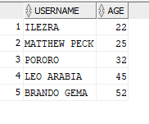

Query 2
English version | Return total of gratuities that a staff got.
Source for the query need in the SRS document | -
SQL sentence | SELECT PU."USERNAME", SUM(GRATUITIES) AS TOTAL_GRATUITIES  FROM P_TRANSACTION PT, P_STAFF PS, P_USER PU  WHERE PT.STAFFID = PS.STAFFID AND PS.USERID = PU.USERID AND PU."USERNAME" = 'BRANDO GEMA'  GROUP BY PU."USERNAME";
Example of returned rows (cropped screen caption) | 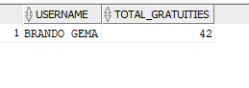

Query 3
English version | Return all staffs who have done at least 2 orders
Source for the query need in the SRS document | -
SQL sentence | SELECT PU."USERNAME", COUNT(*) AS TOTAL_ORDER  FROM P_STAFF PS, P_USER PU, P_ORDER PO  WHERE PO.STAFFID = PS.STAFFID AND PS.USERID = PU.USERID  GROUP BY PU."USERNAME"  HAVING COUNT(*) >= 2;
Example of returned rows (cropped screen caption) | 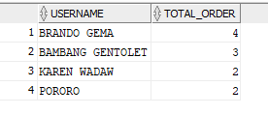

…
Query 4
English version | Return the oldest staff that has schedule on Monday.
Source for the query need in the SRS document | -
SQL sentence | SELECT PU."USERNAME", EXTRACT(YEAR FROM SYSDATE) - EXTRACT(YEAR FROM PU.USERDOB) AS AGE  FROM P_USER PU, P_STAFF PS  WHERE PS.USERID = PU.USERID  AND PU.USERDOB IN (SELECT MIN(PU.USERDOB) FROM P_STAFF PS, P_STAFFSCHEDULE PSS, P_USER PU WHERE PS.STAFFID = PSS.STAFFID AND PS.USERID = PU.USERID AND PSS.SCHEDULE = 'MONDAY');
Example of returned rows (cropped screen caption) | 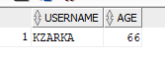

Query 5
English version | Return union between order and transaction. Used to check whether there is an error or not in the order.
Source for the query need in the SRS document | -
SQL sentence | SELECT ORDERID, CUSTOMERID, STAFFID  FROM P_ORDER  UNION  SELECT ORDERID, CUSTOMERID, STAFFID  FROM P_TRANSACTION  ORDER BY ORDERID DESC;
Example of returned rows (cropped screen caption) | 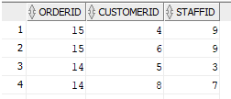  There are errors here where 1 order is reffered to two different customerid.

Query 6
English version | Return all customers whose name starts with J
Source for the query need in the SRS document | -
SQL sentence | SELECT PU."USERNAME"  FROM P_USER PU  WHERE "USERNAME" LIKE 'J%' AND USERROLE = 'CUSTOMER'
Example of returned rows (cropped screen caption) | 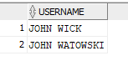

Query 7
English version | Return all ingredients that stock is less than or equal to 100.
Source for the query need in the SRS document | -
SQL sentence | SELECT PI.INGREDIENTSNAME, PI.INGREDIENTSSTOCK  FROM P_INVENTORY PI  WHERE INGREDIENTSSTOCK <= 100  ORDER BY INGREDIENTSSTOCK;
Example of returned rows (cropped screen caption) | 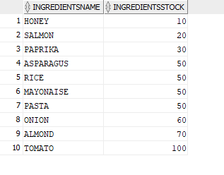

Query 8
English version | Return all dessert that a customer ordered based on customer’s name.
Source for the query need in the SRS document | -
SQL sentence | SELECT PM.MENUITEMNAME  FROM P_USER PU, P_CUSTOMER PC, P_ORDER PO, P_ITEMORDERED PIO, P_MENUITEM PM  WHERE PU.USERID = PC.USERID AND PO.CUSTOMERID = PC.CUSTOMERID AND PO.ORDERID = PIO.ORDERID AND PIO.MENUITEMID = PM.MENUITEMID  AND PU."USERNAME" = 'ANDREW GARFIELD'  AND PM.MENUCATEGORY = 'DESSERT';
Example of returned rows (cropped screen caption) | 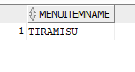

Query 9
English version | Return staff that got the least gratuities
Source for the query need in the SRS document | -
SQL sentence | SELECT PU."USERNAME", SUM(GRATUITIES) AS TOTAL_GRATUITIES  FROM P_TRANSACTION PT, P_STAFF PS, P_USER PU  WHERE PT.STAFFID = PS.STAFFID AND PS.USERID = PU.USERID  GROUP BY PU."USERNAME"  ORDER BY TOTAL_GRATUITIES  FETCH FIRST 1 ROWS ONLY;
Example of returned rows (cropped screen caption) | 